

The NAVIGATE inequality dataset at the income decile level for use in IAMs

Authors: Johannes Emmerling, data collection: Shouro Dasgupta, Simon Feindt, Daniele Malerba, Carolina Grottera

A standardized input data template has been defined and data has been collected using household surveys from a number of developed and OECE countries.

Available countries (for the latest year, between 2008 and 2017, available):

* India, Brazil, France, South Africa, United States of America, China, Mexico
* 26 EU member states based on a common survey

The data is all structured around income deciles. Units of observations for the deciles are households. The OECD modified equivalence scale has been applied to compute household income per person. (1 plus 0.5 per adult (older than 14 years) and 0.3 per child (14 or less years)). Note this definition differs slightly from the OECD’s original definition where adults are 14 years and older. This has been chosen due to the fact that many demographic projections report populations by age cohorts of five years, so we consider 15+ years old as adults.

Available variables (all for deciles D1 to D10):

* Income share
* Expenditure share
* Expenditure share in
  + Energy for Transportation
  + Energy for Housing
  + Food
* Education of the household head
* Average savings rate
* Household size
* Income by type (labour, capital, transfers, other)
* Wealth share (where available)

This shows the availability of countries and variables in the dataset:

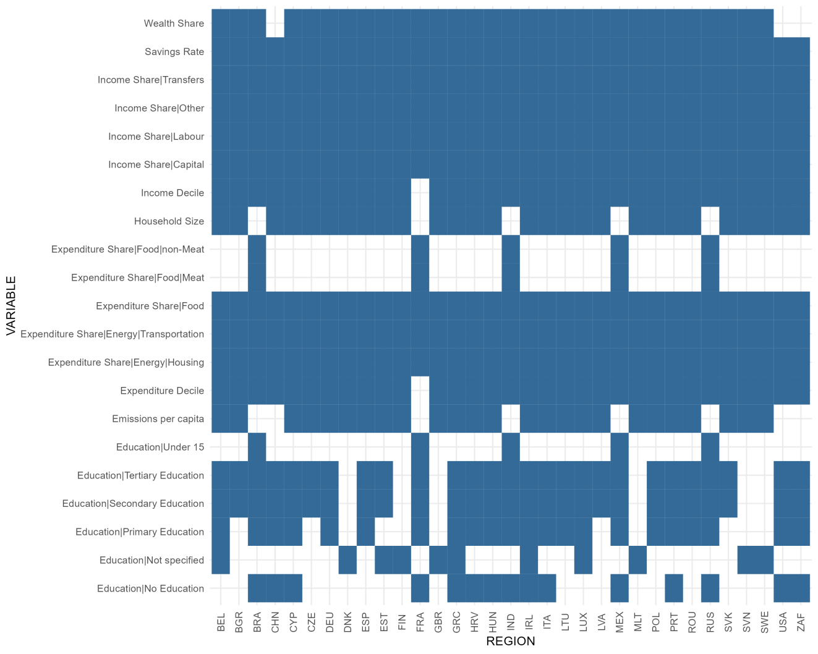

The energy expenditure shares for housing and transportation are key variables for IAMs, and here the expenditure shares across countries, which show a strong regressive pattern for residential energy consumption while for transportation it appears in most countries to be progressive.

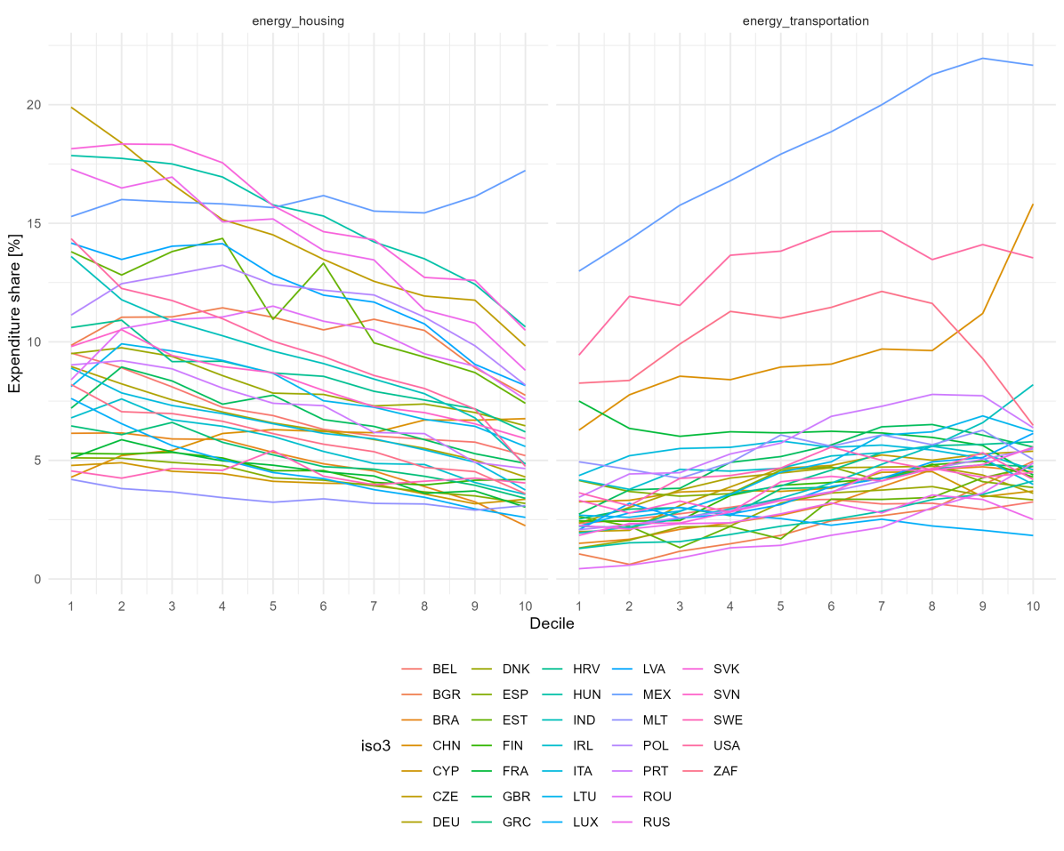

**Sources**:

Mexico: 2018 wave, National Survey of Household Income and Expenditure (ENIGH). The National Institute of Statistics, Geography and Informatics (INEGI). Retrieved from https://en.www.inegi.org.mx/programas/enigh/nc/2018/

Russia: 2019 wave, Russia Longitudinal Monitoring Survey (RLMS-HSE). Higher School of Economics and ZAO “Demoscope” together with Carolina Population Center, University of North Carolina at Chapel Hill and the Institute of Sociology RAS. Retrieved from https://rlms-hse.cpc.unc.edu

India: 2012 wave, National Sample Survey 2011-2012 (68th round) - Consumer Expenditure. Ministry of Statistics & Programme Implementation, Government of India. Retrieved from http://microdata.gov.in/nada43/index.php/catalog/1